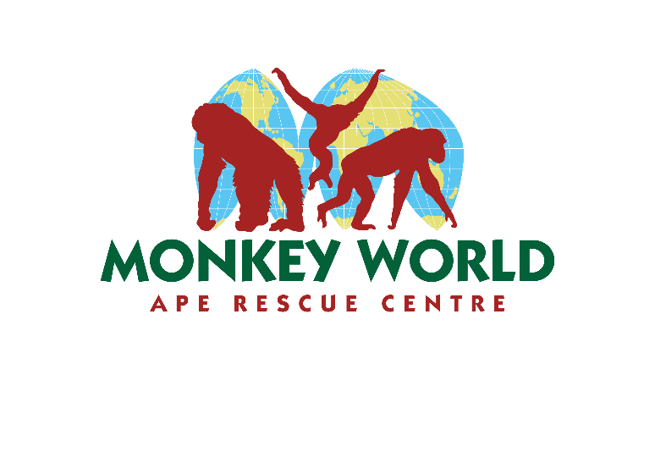

RE: Squirrel Monkey Exhibition
Dear Sir or Madam,
I am writing to you from Monkey World - Ape Rescue Centre in Dorset. We have been made aware that you have squirrel monkeys visiting your residents as an activity.
I'm sorry to have to tell you that this is not good welfare or treatment of squirrel monkeys. Squirrel monkeys are wild animals- not domesticated- no matter whether they were born in captivity or the wild, and they should not be handled or held. Unfortunately they were delisted from the Dangerous Wild Animals Act which led to an upsurge in people keeping them as pets, popularised recently by social media, but at the centre we have rescued squirrel monkeys from the legal UK pet trade for many years.
All come to us with physical or psychological issues. The physical issues can be addressed but the psychological are often harder to tackle. We have some squirrel monkeys who are so humanised that they display neurotic and stereotypical behaviours which we have to work hard to overcome, developing specialist routines and housing for them.
Many of our primates have been rescued from the tourist and entertainment trade. Often, they are stolen from the wild and their families as youngsters, and used as photographers’ props, sitting on tourists’ laps for paid photos. They are controlled with drugs and abuse, and then when they become too old to be exhibited like this- primates become more aggressive after infancy- they are killed.
In April 2025, legislation passed as an addendum to the Animal Welfare Act (AWA) to stop primates being kept as pets in domestic households, and if kept privately must abide to zoo level standards. This includes legislation prohibiting handling them, restraining them on leads, and transporting them other than to the vet.
There is a small loophole, where primates owned under a License for Activities Involving Animals (LAIA) can still be handled. The LAIA part of the AWA will need to be addressed in further legislation as it is not right that in one piece of legislation squirrel monkeys must not be handled, and in another, it is fine for them to be handled. This is the same monkey with the same welfare needs and so it does not follow that it is acceptable in one circumstance and not the other. I am telling you this as background to this legislation. Monkey World was consulted many times on the new legislation, and Dr Alison Cronin, Monkey World’s director was on the steering committee for these new laws.
I suspect the company selling you these visits will tell you that the monkeys are happy, healthy and it is completely safe. Please do be aware that it is in their interests to claim this as this is their business.
They profit from exhibiting their animals to film, TV and experiences such as this. Monkey World is a rescue centre who does not benefit from passing this onto you- in fact it takes us away from other work- but it is vital to our ethos to educate on animal welfare, and help any primates we see in need.
I would also like to draw your attention to the license requirements of LAIA, for your information about whether the needs of the primates can be met during your visit.
- Animals must never be forced to interact with people. They must be able to avoid people, by having a facility such as a hiding place”. Is this provided for during your visit?
- The company exhibiting the primates should have also provided facilities to wash hands / sanitise their hands before & after handling the primates- did this occur?
- The company exhibiting should ensure areas are cleaned prior and after the visit with non-toxic cleansing agents.
- The company exhibiting should ensure any resident / staff member are free of contagious illnesses prior to the visit.
Of course, primate care is an area of our expertise and we do not expect anyone booking these visits to have extensive knowledge of primate welfare. If the company did fulfil all the above requirements then that covers the bare minimum of preventative health care, but still does not cover the fact these are wild animals who do not want or need to be handled- unlike many domesticated animals who may enjoy it. If they did not cover these bare minimum requirements, this should be raised with the council that has issued the LAIA to them.
I would urge you to please reconsider this practise as it is damaging and wholly inappropriate for the primates and also dangerous for residents. Squirrel monkeys are armed with large canines- particularly the males- and can inflict nasty bites. Not to mention the risk of transferring diseases- which goes both ways as monkeys and humans are in the same "primate" family. There is no vaccination for the herpes virus which can cross species, for example.
I would also urge you to reconsider using them in media. It is this kind of normalisation of the practise which has led to the popularity of monkeys as pets- we have rescued over 130 in the past, and have 75 on the waiting list, and the number is growing. Please do look at our website here for more information on our rescue centre, our meetings & petitions with the government & ministers to change the law, & our full information on why primates should not be handled or kept as pets: https://monkeyworld.org/support-us/uk-pet-trade/
I look forward to your response, and hopefully, reconsideration of this practice. There are many domesticated animals which are safer and happier to be handled, instead of wild animals.

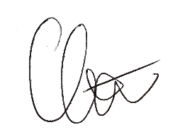
Yours sincerely,

Monkey World – Ape Rescue Centre
Longthorns
Wareham
Dorset
BH20 6HH

