Please find overleaf a sample letter about the change of law concerning primates as pets in the UK
Please personalise with your own details in the relevant sections. You could send a copy of this letter to your own local MP, and the Animal Welfare Minister Lord Benyon.
When you get a reply please send it (or a copy) to:
apes@monkeyworld.org
or
Dr Alison Cronin, STAMPitout, Monkey World - Ape Rescue Centre, Longthorns, Wareham, Dorset BH20 6HH

Thank you for helping to protect pet primates in the UK.

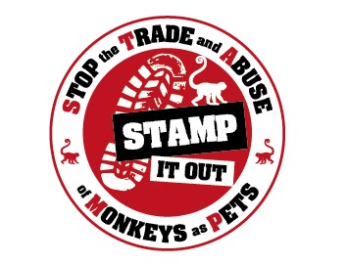
[Your Name]
[Your Address]
[Email Address]
[Phone Number]
[Date]
[Member of Parliament's Name] [Constituency Office Address]
Subject: Upcoming Licensing Scheme Regarding Primates as Pets
Dear [Mr./Ms./Dr. Member of Parliament's Last Name],
I hope this letter finds you well. I am writing to you as a concerned citizen of [Your Constituency] to urgently address an issue that is of paramount importance to the welfare of both animals and our society as a whole – the ownership of primates as pets. As an advocate of animal welfare, I was pleased to see the cross party support for banning the keeping of primates as pets during the 2019 General Election, and again to see it pledged on the Conservative government manifesto on their election to power.
It has come to my attention that now, four years on that there has been little progress on this front. It was promised this would be expedited through law when the Kept Animals Bill was scrapped and the legislation was proposed as an addition to the Animal Welfare Act, meaning standards would be implicit and not brought in through secondary legislation. I read the document provided in the Public Consultation in June 2023 and was pleased to see the robust and thorough considerations of behaviour, companionship, diet, veterinary care and species specific advice for primates living in private ownership, which would bring them in line with zoo standards.
These standards are necessary as primates are intelligent, complex and social mammals that makes them wholly unsuitable for life as a traditional “pet”. Keeping them as pets often results in severe stress, neglect, and suffering.
I am a supporter of the world renowned primate rescue centre, Monkey World – Ape Rescue Centre, and have followed their campaign to change the law to protect pet primates for many years. In 2014 Monkey World director Dr Alison Cronin gave evidence to the EFRA select committee to support a ban in primate ownership, but the law was not changed and instead the Code of Practice for the Welfare of Privately Kept Non-human Primates was bought in. During their recent campaigns, Monkey World has stated that the Code of Practice failed, as it was too general, and not only did it not provide species specific information on how to care for the primates correctly, but also had no “teeth” – it could not bring about confiscation & only was useful in prosecuting owners, not in preventing abuse.
Since the government manifesto pledge in 2019 Monkey World has rescued 24 further primates from the UK pet trade – despite lockdown limitations- bringing the total rescued to 130, and currently has over 75 on their waiting list. The problem is not going away and is in fact growing.
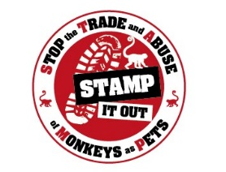
I write to you to ask you to speak up for pet primates at this time and urge the government not to stray from their aims of protecting primates living in the UK today, by allowing the standards to become vague and “cover-all”. While the aim of moving to the Animal Welfare Act was to avoid “scope creep” and to bring standards into law, the fear is history will repeat itself and the high and species-specific standards required will become diluted and indistinct, and so negating the process. The Code of Practice failed as it was full of non-specific phrases such as “appropriate to the species” and “suitable environment”. Standards cannot be expected to be enforced if they are not clear and specific. Diluting standards will render the legislation meaningless.
It would be a tragedy if more primates continued to suffer in pet trade homes because of bureaucracy coming before animal welfare in the UK, a kingdom of “animal lovers”. I would be incredibly disappointed if the Conservative government did not uphold its 2019 manifesto pledge in effectively banning the keeping of primates in unsuitable conditions as “pets”.
I understand that this is a complex issue, and I would be more than willing to provide additional information or meet with you to discuss it further. I firmly believe that by working together, we can make a significant difference in improving animal welfare and public safety.
Thank you for your attention to this crucial matter. Your support in advocating for this matter would be greatly appreciated.
Sincerely,
[Your Name]

